**Methodology:**

**Maxent- Variable selection, which variables and why?**

Bio1: Annual Mean Temperature

Bio4: Temperature Seasonality

Bio5: Max temperature of warmest month

Bio12: Annual Precipitation

Plant growth depends on temperature and precipitation. Buckwheat requires a cool, moist environment and is not frost resistant.

**Model Output**

**Present + Future Distribution Map**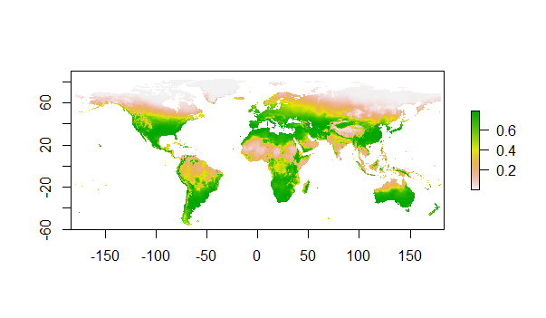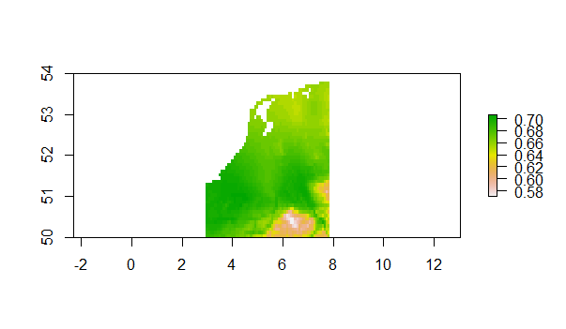

We can see here that when looking at climate variables there is a much greater suitable habitat when compared to occurrence of species. I only used the occurrence data from the Netherlands (therefore we only see the nl map here). In other models we may have un-sampled or unrepresented areas from knowledge gaps in the database.

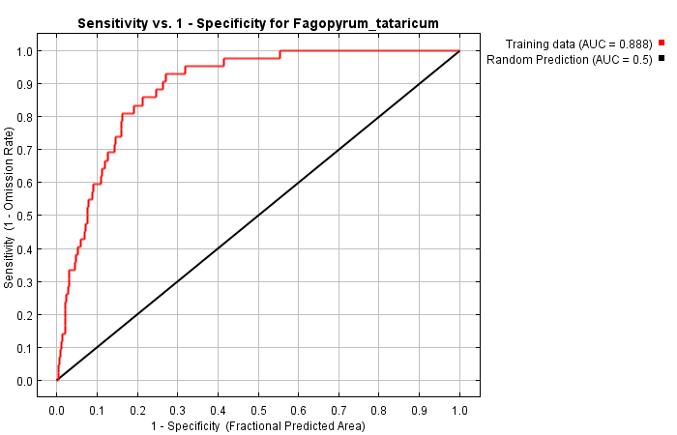**Model Performance- AUC**

Analysis of omission/commission shows that the data follows the training data well (AUC=0.888). (good model with high AUC)

|  |  |  |
| --- | --- | --- |
| **Variable** | **Percent contribution** | **Permutation importance** |
| bio1 | 33.6 | 48.7 |
| bio4 | 33.1 | 18 |
| bio12 | 25.6 | 28 |
| bio5 | 7.7 | 5.3 |

**Variable Importance Table**

Here we can see that the driving variable for distribution is bio1. Bio12has a perceivable amount of importance and bio4 can also be considered important. Bio5 comes in as the least important variable.

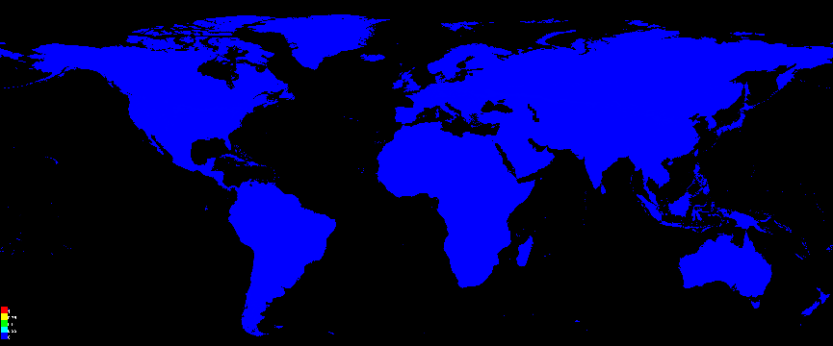

This graph shows that the variables values are not extreme.

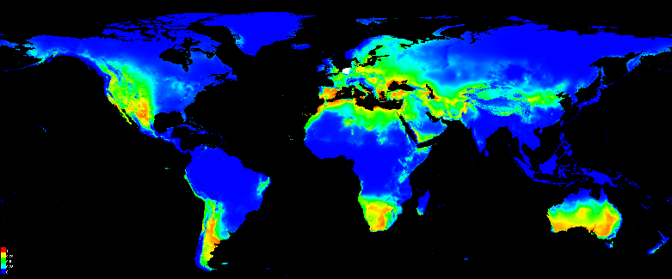 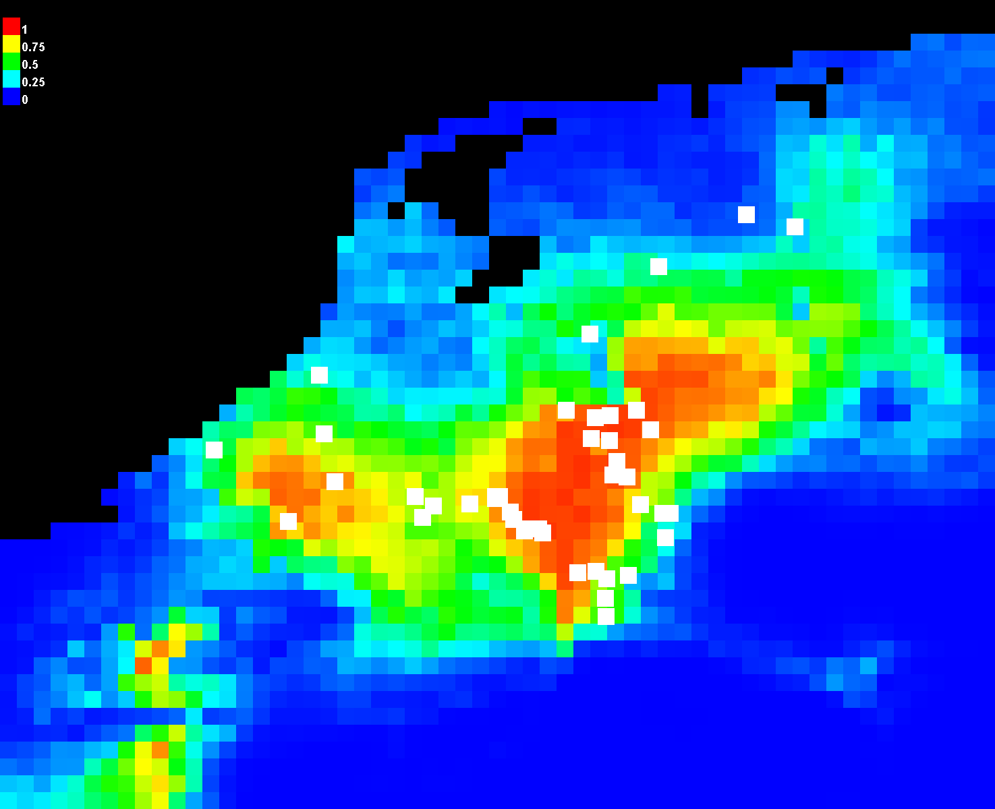

Warmer colours on these map shows us the areas with the better predicted conditions for *Fagopyrum tataricum*. White dots show the presence locations used for training, while violet dots show test locations.

**Future Distribution Change Maps**

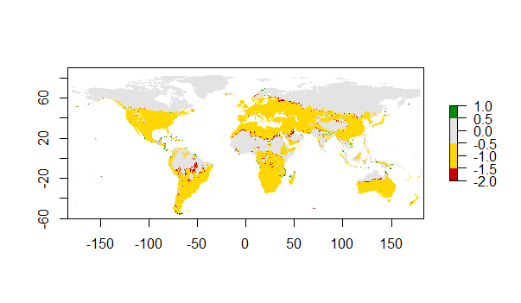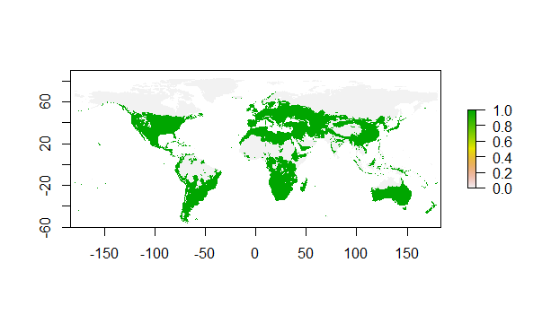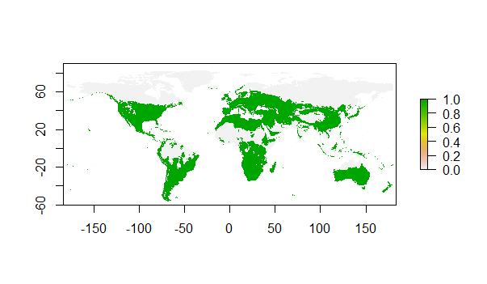Here we see that there is very little difference between present and future distribution- suggests that there is not a strong effect of climate change under scenario (…2050)- the distribution of buckwheat is affected by other factors.

Here we can see the habitat suitability at global scale in the future. Grey is never suitable, yellow remains suitable and green is gained. We can see a few areas gained eg) Central america area and east Africa. Some areas are lost (in red).

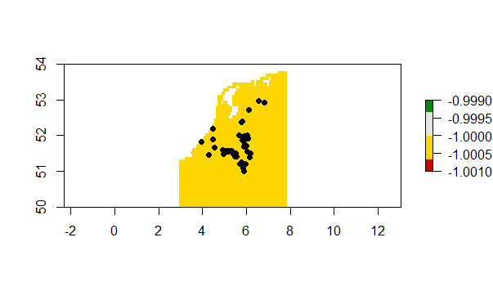

This graph shows the difference between present and future in habitat suitability at occurrence scale. Because we only used NL occurrence data this shows the NL map only. It appears there will be no change in this area for habitat suitability.

**Biological Interpretation**

Distribution: The expected distribution changes using this model suggests that most areas remain suitable for *Fagopyrum tataricum.* Small areas are gained for example in Central America and East Africa. Similarly a few areas are also lost, in general the areas lost are still larger than the areas gained. Areas lost can be seen appearing along eastern Europe, Northern Australia, around South America (mostly the northern middle areas and the south) and north Africa. There appears to be some latitudinal patterns of unsuitability along eastern Europe and Northern Africa. The areas lost create a sort of line due to possible temperature differences (eg in northern Africa the line is created where there appears to be more dessert and a higher temperature and possible low precipitation (the same may apply for the Australian lost region) as buckwheat requires moist and cool conditions to grow. In the line separating eastern Europe towards the Russian continent we may predict that this is due to the effect of colder temperatures (buckwheat is frost intolerant).

Whatever the reasons behind the change in conditions that lead to unsuitable habitats this could cause a decrease in the range of buckwheat.

We must be critical of this model: the occurrence data of *Fagopyrum tataricum* comes from the Netherlands. Therefore applying these occurrence data to a worldwide climate model is inappropriate. A better prediction is to compare the data to the future predictions for the Netherlands alone. By looking at this map we see no changes in habitat suitability. Therefore our prediction would be that in the Netherlands there will be no loss or increase in *Fagopyrum tataricum.* However this model does not take into account soil type, nutrients and many other biotic (predation, competition etc) and abiotic factors that may influence distribution with a changing climate. The climate model may also lack information and be biased towards areas with more data. Climate models are also not able to predict some interactions that may come from the changing conditions (although a good climate model is relatively good at this).

Implications to these results may be to identify areas in the world where *Fagopyrum tataricum* can be grown as a potential food source. This information can also be used to suggest to farmers in areas to stop growing *Fagopyrum tataricum* and to start preparing to start planting alternative plants. When not cultivated but found among other crops *Fagopyrum tataricum* is considered a weed. Therefore we may predict that this plant may arise as a weed in areas that it was previously not found (which may mean that farmers will have to create pest control for this species). On the other hand this data is not enough to cause any sort of reliable changes but could be a base to see how the plant could react to changing conditions and to predict how patterns may change with similar species.